**Reproduction**

**Content**

Differentiation:

* embryonic germ layers and tissues formed from the primary germ layers
* types of stem cells, their potency and importance (*e.g. cord blood* )
* teratogenic effects on stem cells

Reproductive systems:

Four-week old embryo

http://images.wellcome.ac.uk/

* structure and function of male and female reproductive systems
* spermatogenesis and oogenesis
* 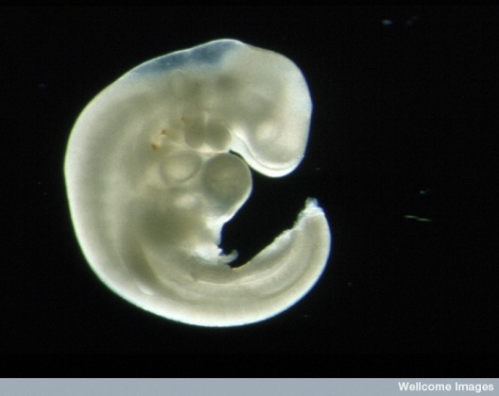hormonal control of menstrual and ovarian cycles and spermatogenesis.

Development:

* implantation and development of the placenta
* significant developments in embryonic and foetal stages
* changes to a female during pregnancy
* birth process
* comparison of foetal and neonate circulation
* patterns and milestones of development in infants

Reproductive technologies related to:

* contraception, infertility (*e.g. IVF, GIFT donors)* andconception
* maintenance of pregnancy including ultrasound, foetal monitoring and hormonal intervention.

Causes, symptoms and treatment of sexually transmitted infections (STI)

Medical technologies related to sex selection of the embryo to avoid genetic disease and birth control methods. Health choices related to pregnant women (*e.g. warnings on food labels, drugs, alcohol and smoking*) and parent’s choice for infants (*e.g. diet and immunisation choices.*)

**Questions from Text**

Chapter 10 Chapter 11

Review Questions: 1-9 Review Questions: 1-9

Apply Your Knowledge: 3-5 Apply Your Knowledge: 1-6

Chapter 12 Chapter 13

Review Questions: 1-13 Review Questions: 1-14

Apply Your Knowledge: 1, 2, 6 & 7 Apply Your Knowledge: 1-3, 5 & 8

Chapter 14 Chapter 15

Review Questions: 1-8 Review Questions: 1-10

Apply Your Knowledge: 1, 2, 3 & 7 Apply Your Knowledge: 1, 5 & 8

Chapter 16

Review Questions: 1-10

Apply Your Knowledge: 1 & 3-5